Module: Embedded C Hardware+ Programming+ Testing



./



Learning Report

–

Embedded C

**Document History**

|  |  |  |  |  |  |
| --- | --- | --- | --- | --- | --- |
| **PS. No.** | **Release Date** | **Prepared. By** | **Reviewed By** | **Approved By** | **Remarks/Revision Details** |
| 99003752 | 19/03/2021 | Sushma L  Nagangoudra |  |  |  |

**Contents**

**ACTIVITY 1**–COMPILATION APPROACH……………………………………………………………………………………………………………….4

1.1 MAKE FILE .............................................................................................................................................................4

1.2 STARTUP CODE……………………………………………………………………………………………………………………………………………….5

1.3 LINKER FILE……………………………………………………………………………………………………………………………………………………..8

1.4 DEBUGGING TECHNIQUES……………………………………………………………………………………………………………………………….9

**ACTIVITY 2**–IMPLEMENTATION OF PROTOCOLS USING STM IDE ...........................................................................10

2.1 GPIO……………………………………………………………………………………………………………………………………………………………..10

2.2 EXTI……………………………………………………………………………………………………………………………………………………............12

2.3 ADC……………………………………………………………………………………………………………………………………………………............14

2.4 SPI………………………………………………………………………………………………………………………………………………………………….17

2.5 UART……………………………………………………………………………………………………………………………………………………………..19

**1.Selection of Car-GMC Sierra**

**Introduction**

**1.Airbag System**

The purpose of the air bag is to provide a cushion between the occupants and the vehicle’s interior. For air bags to be effective they have to be fully inflated in a short amount of time, before the occupants make contact with them however, this rapid inflation can potentially cause fatal injuries to certain people if they are in contact with the air bag during its inflation. Therefore, air bags must have a control system that can recognize a crash correctly, and early enough for the air bags to inflate safely.

**2. Research and Literature Survey**

**2.1 Features**

* Air bags are supplemental protection and are designed to work best in combination with seat belts.
* Airbags are passive safety features designed to mitigate or prevent injuries among drivers and passengers in the event of a crash.
* Airbags provide added protection to seatbelts. For example, in higher-speed crashes, a seatbelt alone may not prevent a driver's head from hitting the steering column.

**2.2 Inputs:**

2.2.1CRASH SENSOR HISTORY

Early air bag deployment systems in older vehicles utilized mechanical sensors for crash detection, Early mechanical sensors, such as the “rolamite” by Sandia National Laboratories, relied on a metallic sphere that was stabilized at a standby position by a spring or a magnet.

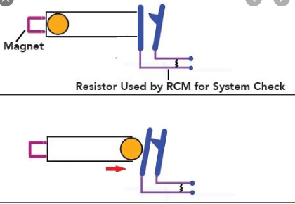

Source: <https://www.motor.com/magazine-summary/supplemental-restraint-service-january-2020>

2.2.2 MEMS Sensor

New MEMS crash sensors measure acceleration with an accelerometer that sends a continuous stream of data to the air bag control module. Accelerometers are typically piezoelectric or variable capacitance sensors. The most common MEMS accelerometer in use today is the ADXL-50 by Analog Devices. As an anchored mass moves relative to the sensor’s body due to acceleration, a plate attached to the anchored mass moves closer to a stationary plate. The change in distance between the plates affects the capacitance of the sensor, or the ability to hold an electrical charge. This change in capacitance is easily measured and is then converted to a change in voltage. The voltage change is directly correlated to force due to acceleration, and the readings are interpreted as acceleration by the air bag control module. Using an algorithm, the control module can determine if air bag deployment is necessary based on the pattern of the acceleration pulses over time.

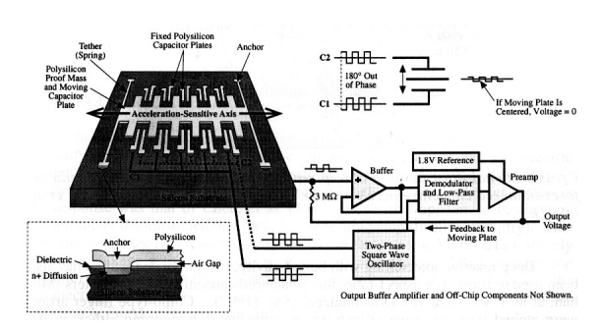

One of the pioneers in fabricating accelerometers in integrated circuit form is Analog Devices, which produces the ADXL50 accelerometer.  The ADXL50 provides an output voltage that varies proportionally with the amount of acceleration experienced along its sensitive axis. It has an input range of -50g to +50g, with a sensitivity of approximately 1 V per 50 g.  Thus, a 50-g acceleration would either decrease or increase the output at 0 g by 1V, depending on the direction of the acceleration.  Since the ADXL50 is calibrated to output 1.8V when there is no acceleration, the output would either 0.8 V or 2.8 V at 50 g, again depending on the acceleration's direction.

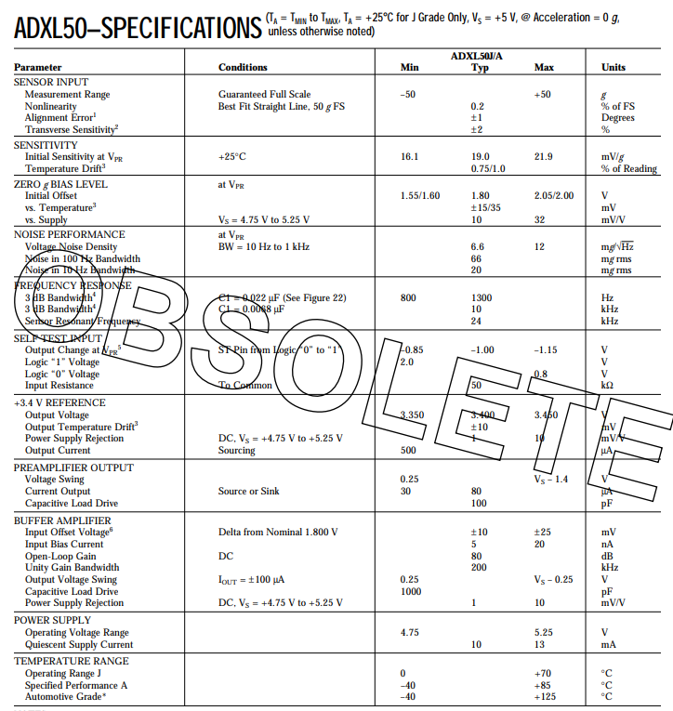

Source: <https://www.analog.com/media/en/technical-documentation/obsolete-data-sheets/2044696ADXL50.pdf>

**2.3 Algorithm**

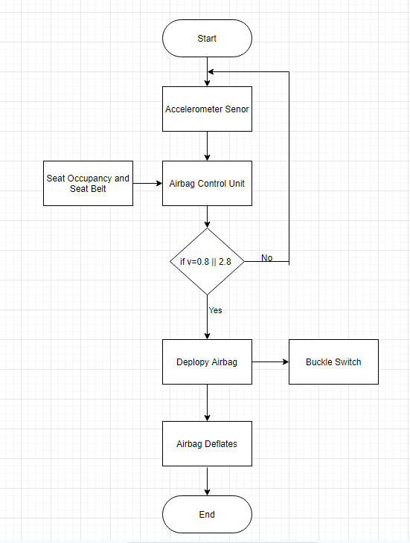

**2.4 Output**:

Squib Driver: To fire the gas generators and inflate Airbag.

Loosen the Buckle switches at Seatbelt

**3.SWOT Analysis**

|  |  |
| --- | --- |
| Strength   * Airbags prevent injuries among drivers and passengers in the event of a crash. * Airbags is effective to fully inflated in a short amount of time | Weakness   * Air bags do not replace the need for seat belts. Some people wearing no belt or only a lap belt have been hurt and killed by the deployment of the airbag. * Once the airbag is deployed it has to be replaced by the consumer, which costs about $500-$2000. |
| Opportunities   * The market for airbag has been growing at a higher pace than that of automotive market due to increasing awareness towards passenger safety. | Threats   * Active safety systems will overtake passive protection, such as airbags. These advanced systems can impose serious threats to airbag industry. |

**4.Requirements**

**High level Requirement**

|  |  |  |  |
| --- | --- | --- | --- |
| Requirement | Before | After | Range |
| Detection of Crash | Detection of crash using crash sensor | Detection of crash using Accelerometer | -50g to +50g (0.8V to 2.8V) |
| Deployment of airbag | Deployment of airbag | Deployment of airbag and deflate after few seconds | 300°-400° F. |

**Low level requirement**

|  |  |  |
| --- | --- | --- |
| Requirement | Before | After |
| Seat Occupancy | Using Seatbelt | Using Pressure Sensor |
| Seatbelt | Using Seatbelt status | Using Seatbelt Warning Module |
| Seatbelt Tighten | Seatbelt as it was before accident | Tighten the seat belt |

**2. Power Door Lock System**

Power door locks (also known as electric door locks or central locking) allow the driver or front passenger to simultaneously lock or unlock all the doors of an automobile or truck, by pressing a button or flipping a switch.

**2.2 Inputs**

When it comes to power door lock circuits, you need to understand that there are multiple types that all accomplish the same job. These can vary by manufacturer and can even vary among vehicles made by the same manufacturer. At the end of the day, the operation of the circuit is the same. Press the unlock switch and the doors unlock; press the lock switch and the doors lock.

Most of the door lock actuators are of the two-wire variety, no matter the manufacturer, OEM, or aftermarket supplier. Apply power to one wire and ground to the other and the actuator moves one way; reverse this and the actuator moves the other way. This is commonly referred to as “voltage reversal” and is the way things have been done in vehicles for a very long time. What varies is the way the switching is done to get voltage and ground to the motors. Here are four of the most common switching methods:

* Negative Pulse
* Voltage Reversal Rest at Ground
* Variable Voltage

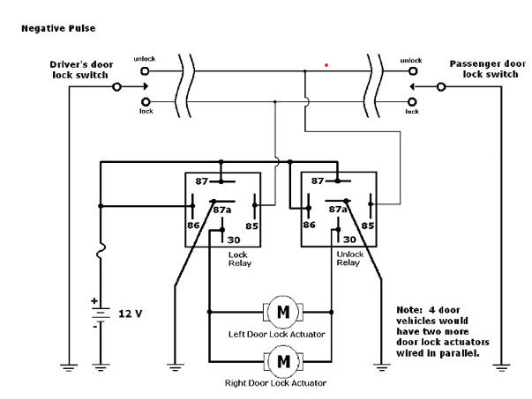

Source: <https://www.musclecardiy.com/automotive-wiring/automotive-power-accessories-and-charging-systems/>

Voltage Reversal

This circuit does not use relays. Instead, a pair of D.P.D.T. switches is wired in series and the overall circuit rests at ground. Note that one of the switches has four wires, and the other has five wires. The four-wire switch is the MASTER and the five-wire switch is the SLAVE. This over-all circuit is easy as both actuator wires rest at ground as a result of the switches resting at ground. When one switch is depressed, it:

* Sends +12VDC to one of the lock/unlock wires, which causes the actuators to move in the corresponding direction.

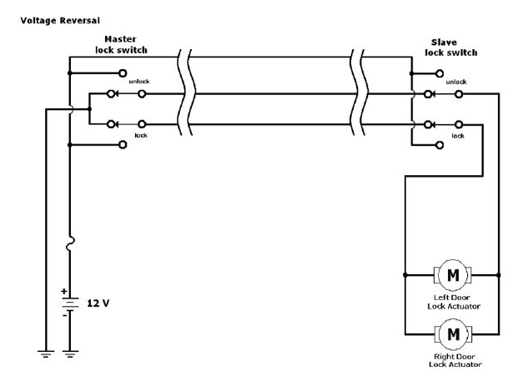

Source: <https://www.musclecardiy.com/automotive-wiring/automotive-power-accessories-and-charging-systems/>

Variable voltage

Variable voltage (analog) configurations (Figure 5-4) use a single wire to send multiple signals to a controller and, as the name implies, these signals vary in voltage. The first vehicle I remember working on that used this type of door-lock circuit was the Ford Probe, which was actually built by Mazda. Today this is commonplace, especially in Chrysler vehicles for the last 10 years or so. A variable-voltage system requires some kind of controller between the switch and actuators as shown. This controller decodes a voltage level as a command and takes the appropriate action.

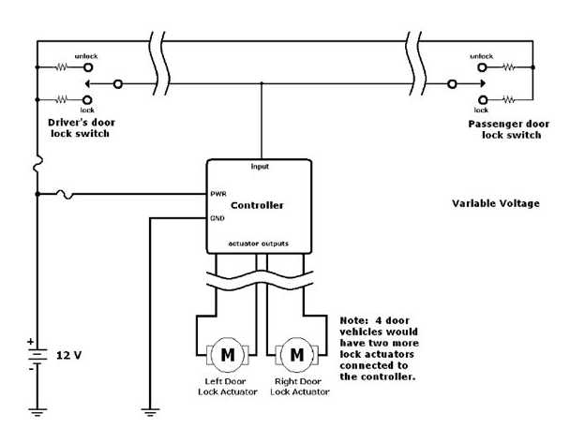

Source: <https://www.musclecardiy.com/automotive-wiring/automotive-power-accessories-and-charging-systems/>

## Output: High Power 2 Wire Door Lock Actuator

